- Description of an output file for det task
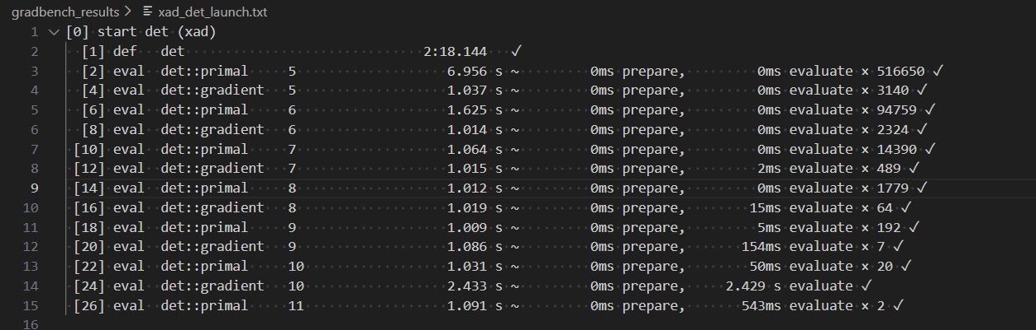
1st column: [0] … [26] – the number of a test in testing process
2nd column: start, def, eval.
Start – it means the launch of testing process of the task using a particular library (XAD in this case).
Def – a preparation step and building of the task. This step is not included in the results of the testing.
Eval – on this step there is a running a task in a cycle with measurement of calculating time
3rd column: det:: primal, det::gradient
Det::primal - It calculates only the output of the function, which is the determinant of the input matrix.
Det::gradient - It calculates the determinant and the gradients (partial derivatives) of the determinant with respect to every single element of the input matrix.
4th column: 5..11 – an input data size. For the determinant task (det), this is the matrix dimension. For example, 7 means a 7x7 matrix.
5th column: The total time spent on this test running
6th column: 5 ms prepare (for example). It shows a total time for preparation for a test run: generation of the matrix, variables initialization.
7th column: 5ms evaluate × 192 (for example). 5ms evaluate is an average execution time of one calculation in the test running. If it says 0ms, it means the task executes in less than 1 millisecond.
192 means how many times this task was launched. If running of the task lasts less than 1 second, the benchmark continues to launch it until the total test time will reach 1 second.
8th column: yes or no – was the test successful or not.

- Description of an output file for GMM task
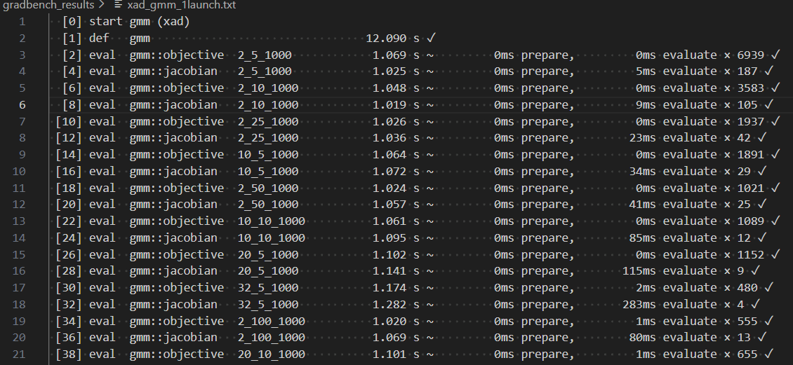
1st column: [0] … [38] – the number of a test in testing process
2nd column: start, def, eval.
Start – it means the launch of testing process of the task using a particular library (XAD in this case).
Def – a preparation step and building of the task. This step is not included in the results of the testing.
Eval – on this step there is a running a task in a cycle with measurement of calculating time
3rd column: gmm:: objective, gmm::jacobian
Gmm::objective - the program calculates the error (negative log-likelihood) of the GMM model.
Gmm::jacobian - the program calculates the target function and its gradients (matrix of first derivatives) for all parameters in the model.
4th column: Input parameters. For the GMM task in Gradbench, these are three numbers separated by underscores (d_k_N). For example, in test 32_5_1000:
d = 32: Data dimensionality (64 features).
k = 5: Number of gaussian components (clusters).
N = 1000: Number of data points (samples).
5th column: The total time spent on this test running. For example, 1.282 s ~
6th column: it is time to prepare data before calculation (reading, allocating memory).
7th column: 1ms evaluate × 555 (for example). 1ms evaluate is an average execution time of one calculation in the test running. If it says 0ms, it means the task executes in less than 1 millisecond.
555 means how many times this task was launched. If running the task lasts less than 1 second, the benchmark continues to launch it until the total test time will reach 1 second.

8th column: yes or no – was the test successful or not.
- Description of an output file for LLSQ task

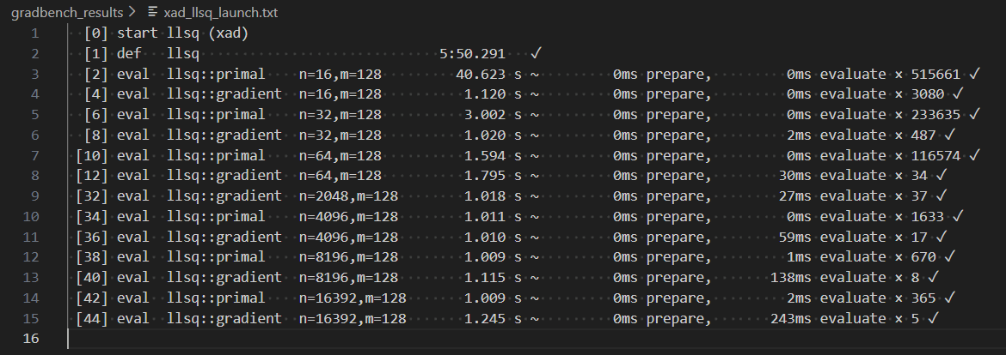
1st column: [0] … [44] – the number of a test in testing process
2nd column: start, def, eval.
Start – it means the launch of testing process of the task using a particular library (XAD in this case).
Def – a preparation step and building of the task. This step is not included in the results of the testing.
Eval – on this step there is a running a task in a cycle with measurement of calculating time
3rd column: llsq:: primal, llsq::gradient
llsq::primal: it computes only the objective function (the sum of squared errors).
llsq::gradient: This computes the error and the gradients (derivatives).
4th column: n and m. For example:
n = 16392: it is the size of the dataset (number of observations). The algorithm evaluates its accuracy against 16392 points. In the benchmark, n doubles in each step.
m = 128: it represents the complexity of the model. These are the 128 coefficients that the algorithm is trying to optimize to find the best model for the data.
5th column: The total time spent on this test running
6th column: 0 ms prepare (for example). It shows a total time for preparation for a test run.
7th column: 1ms evaluate × 670 (for example). 5ms evaluate is an average execution time of one calculation in the test running. If it says 0ms, it means the task executes in less than 1 millisecond.
670 means how many times this task was launched. If running the task lasts less than 1 second, the benchmark continues to launch it until the total test time will reach 1 second.
8th column: yes or no – was the test successful or not.
- Description of an output file for ODE task
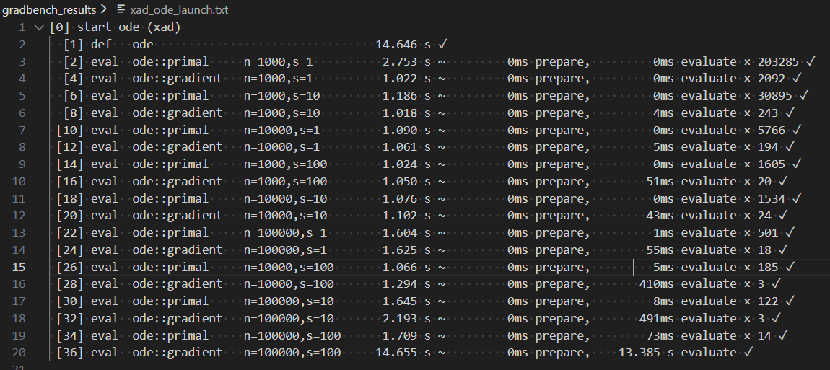
1st column: [0] … [36] – the number of a test in testing process
2nd column: start, def, eval.
Start – it means the launch of testing process of the task using a particular library (XAD in this case).
Def – a preparation step and building of the task. This step is not included in the results of the testing.
Eval – on this step there is a running a task in a cycle with measurement of calculating time
3rd column: ode:: primal, ode::gradient
ode::primal: calculates only the solution to the equations. The algorithm takes a specified number of time steps (s steps) to determine the final state of a system of n variables.
ode::gradient: calculates the final state of the system and gradients (derivatives).
4th column: n and s. For example:
n is the system dimension (number of equations or state vector size). In the last test, it reaches 100000.
s is the number of integration steps. This is the number of times the algorithm takes a step in time to obtain the final result.
5th column: The total time spent on this test running
6th column: 0 ms prepare (for example). It shows a total time for preparation for a test run.
7th column: 491 ms evaluate × 3 (for example). 491 ms evaluate is an average execution time of one calculation in the test running. If it says 0 ms, it means the task executes in less than 1 millisecond.
3 means how many times this task was launched. If running the task lasts less than 1 second, the benchmark continues to launch it until the total test time will reach 1 second.

8th column: yes or no – was the test successful or not.

